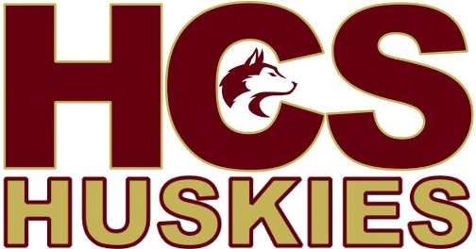
Middle School Girls Invitational
Maroon | Gold
Hartland  Harvey  Florenceville | Meduxnekeag  John Caldwell  Nackawic

Saturday, December 17 |  | Sunday, December 18th
10:00  11:45  1:30  3:15  5:00  6:45 | NMS vs. MCS  Harvey vs. HCS  JCS vs. NMS  FMS vs. Harvey  MCS vs. JCS  HCS vs. FMS | 10:00  11:45  1:30  3:15 | Semifinal - M1 vs G2  Semifinal - G1 vs M2  Consolation - M3 vs G3  Final

Warm up will be 15 minutes and start as soon as preceding game has finished.
Coaches will select player of the game from their own team
A banner will be awarded to the winning team
Admission - $5 for day pass, $8 for a tournament pass
Tournament fee is $250. Please make cheques payable to Hartland Community School

Questions or comments please contact:
Claire Dunlop – Head Coach – claire.dunlop@nbed.nb.ca
Jamie Allison – Athletic Director – james.allison@nbed.nb.ca

